ASSIGNMENT

***LAB SHEET 4***

***WAQAS ASHIQ.***

***BCS-F11-201.***

***SECTION.C***

***SUBMITTED TO : SIR BILAL HASSAN.***

***EXRCISE#1:***

***/*ENTER AN ARRAY AND PRINT IT SUM AND AVERAGE*/***

***CODE:***

#include<stdio.h>

#define SIZE 10

int main()

{

int a[SIZE];

int sum=0;

float average;

int i;

for(i=0;i<+SIZE;i++)

{

printf("\nEnter the array elements :\t");

scanf("%d",&a[i]);

sum+=a[i];

average=(float) sum/SIZE;

}

printf("\nThe sum of array elements is:\t%d\n\nThe average is :\t%.2f",sum,average);

printf("\n\n\n");

}

***OUTPUT:***

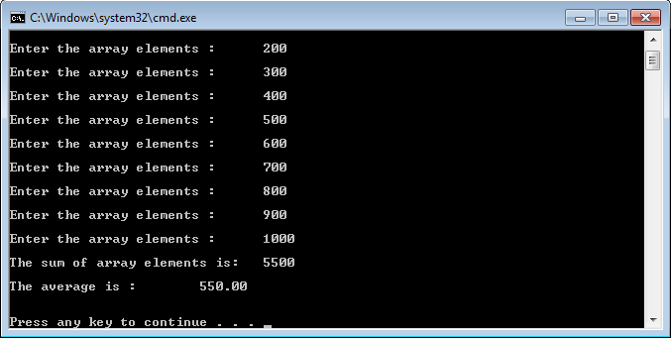

***EXERCISE:#2***

***/*max and min in multisubscripted array*/***

***CODE:***

#include<stdio.h>

int main()

{

int a[2][5];

/*declaring multi subscripted array*/

int max1=0;

int max2=0;

int min1=0;

int min2=0;

int max=0;

int min=0;

int i=0;

int j=0;

for(int i=0;i<2;i++)

/*storing numbs in multi subscripted array*/

{

printf("enter the number:\t");

scanf("%d",&a[i][j]);

for(int j=1;j<5;j++)

{

printf("enter the numbes:\t");

scanf("%d",&a[i][j]);

}

}

for(int j=0;j<5;j++)

/*finding max in each row*/

{

if(a[0][j] > max1)

{

max1 = a[0][j];

}

}

for(int j=0;j<5;j++)

{

if(a[1][j] > max2)

{

max2 = a[1][j];

}

}

/*printing max in each row*/

printf("\nthe max in row1:\t%10.d\nthe max in row2:\t%11.d",max1,max2);

for(int j=0;j<5;j++)

/*finding min in each row*/

{

if(a[0][j] < min1 ||min1 == 0 )

{

min1 = a[0][j];

}

}

for(int j=0;j<5;j++)

{

if(a[1][j] < min2 || min2==0)

{

min2 = a[1][j];

}

}

/*printing min in each row*/

printf("\nthe minimun in row1 is:%11.d\nthe minimum in row2 is:%11.d\n",min1,min2);

/*finding max in min in whole array*/

if(max1>max2)

{

max=max1;

}

if(max2>max1)

{

max=max2;

}

if(min1<min2)

{

min=min1;

}

if(min2<min1)

{

min=min2;

}

/*printing max in min in whole array*/

printf("the max in whole array is:\t%d\nthe min in whole array is:\t%d\n\n\n",max,min);

}

***Output:***

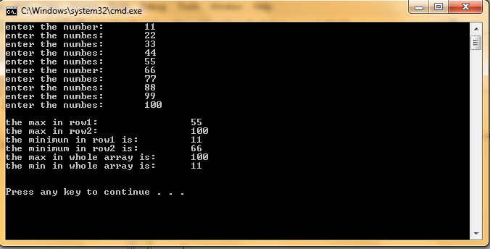

***EXERCIES#3.***

***CODE:***

#include<stdio.h>

void main()

{

char a[10][12];

int b[10];

for (int i=0; i < 10; i++)

{

printf("Enter the name of town no.%d:\t",i+1);

scanf("%s", &a[i]);

printf("Enter the distance of town from london:\t");

scanf("%d", &b[i]);

printf("\n");

}

printf("\nTowns With Distance<100miles from London are:\n");

for (int i=0; i < 10; i++)

{

if (b[i] < 100)

printf("\n%s is %d miles from london.\n", a[i], b[i]);

}

printf("\n\n\n");

}

***OUTPUT:***

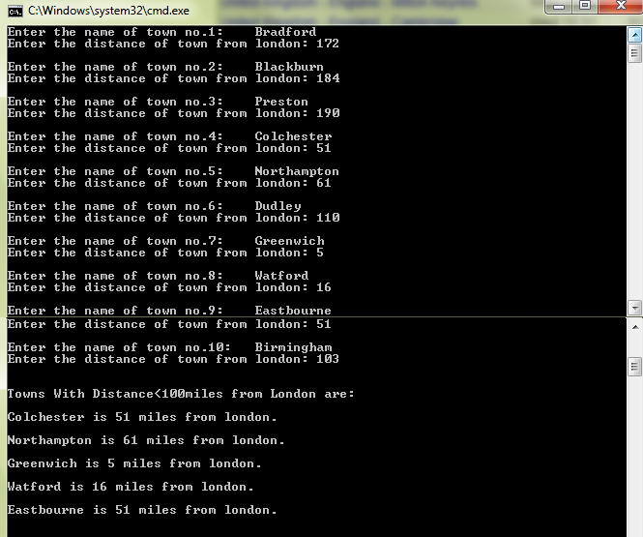

***QUESTION#5***

***CODE:***

#include <stdio.h>

void main (void)

{

char A[4][12]={ 0 };

for (int i=0; i < 4; i++)

{

printf("Enter A Character String: ");

scanf("%s", &A[i]);

}

for (int i=3; i >= 0; i--)

{

printf("%s\t", A[i]);

}

printf("\n");

for (int i=0; i < 4; i++)

{

for (int j=10; j >= 0; j--)

{

if (A[i][j] != 0)

printf("%c", A[i][j]);

}

printf("\t");

}

printf("\n");

for (int i=3; i >= 0; i--)

{

for (int j=10; j >= 0; j--)

{

if (A[i][j] != 0)

printf("%c", A[i][j]);

}

printf("\t");

}

printf("\n");

}

***OUTPUT:***

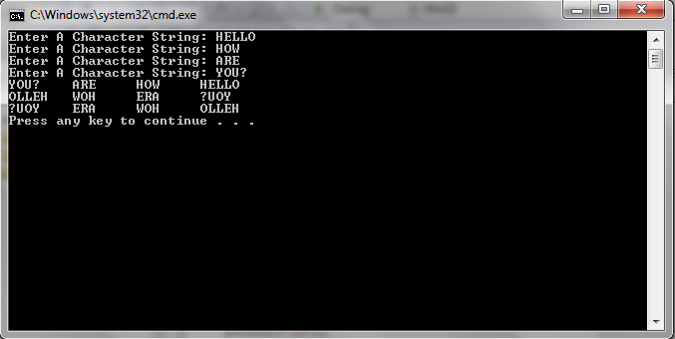

***QUESTION#4***

***CODE:***

#include<stdio.h>

float calculate_salary(float);

void record_sales(int [], float);

void print_array(int []);

void main()

{

int A=0, RECORD[3] = {0, 0, 0};

float B=0, SALARY[20];

while (B != -1 || A != 20)

{

printf("Enter Worker's Gross Sales: $");

scanf("%f", &B);

if (B == -1)

break;

SALARY[A] = calculate_salary(B);

printf("\tWorker's Salary This Week: $%0.2f\n", SALARY[A]);

record_sales(RECORD, SALARY[A]);

A++;

}

print_array(RECORD);

}

float calculate_salary(float X)

{

int Z;

Z = (200 + (0.09 * X));

return Z;

}

void record_sales(int RECORD[], float Y)

{

if (Y >= 200 && Y <= 500)

RECORD[0]++;

else if (Y >= 501 && Y <= 999)

RECORD[1]++;

else

RECORD[2]++;

}

void print_array(int RECORD[])

{

printf("\n\nSALARY OVERVIEW\n");

printf("SALARY RANGE $200-$500: %10d\n", RECORD[0]);

printf("SALARY RANGE $501-$999: %10d\n", RECORD[1]);

printf("SALARY RANGE $1000 & ABOVE: %6d\n", RECORD[2]);

}

***OUTPUT:***

